Name | Function | IP Address | Operating System
Jump Box | Gateway | 168.61.53.77  10.0.0.4 | Linux
Web Server-1 | Web Server | 10.0.0.5 | Linux
Web Server-2 | Web Server | 10.0.0.6 | Linux
Web Server-3 | Web Server | 10.0.0.8 | Linux
Elk Server | Web Server | 13.65.194.32  10.1.0.4 | Linux

Access Policies:

Name | Public Access | Allowed IP Address
Jump Box | Yes | 168.61.53.77  10.0.0.4
Webserver-1 | No | 10.0.0.5
Webserver-2 | No | 10.0.0.6
Webserver-3 | No | 10.0.0.8
ELK | No | 13.65.194.32  10.1.0.4
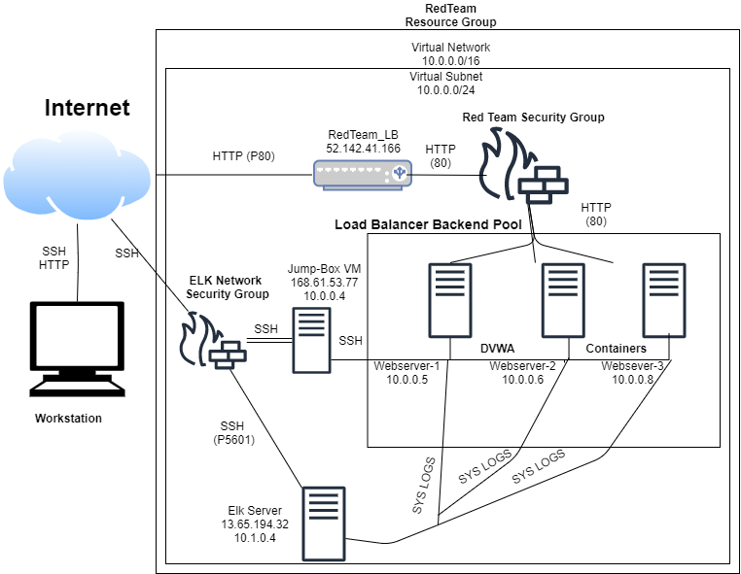

SSH into Jumpbox:
Ssh into jumpbox run container

docker container start gracious curie
docker container attach gracious curie

As in the container your able to run and create different playbooks and set up the VM

ELK Playbook:

nano etc/ansible/ansible-playbook elk.yml

---
# install_elk.yml
- name: Configure Elk VM with Docker
hosts: elkservers
remote_user: elk
become: true
tasks:
# Use apt module
- name: Install docker.io
apt:
update_cache: yes
name: docker.io
state: present

# Use apt module
- name: Install pip3
apt:
force_apt_get: yes
name: python3-pip
state: present

# Use pip module
- name: Install Docker python module
pip:
name: docker
state: present
# Use command module
- name: Increase virtual memory
command: sysctl -w vm.max_map_count=262144

# Use sysctl module
- name: Use more memory
sysctl:
name: vm.max_map_count
value: "262144"
state: present
reload: yes

# Use docker_container module
- name: download and launch a docker elk container
docker_container:
name: elk
image: sebp/elk:761
state: started
restart_policy: always
published_ports:
- 5601:5601
- 9200:9200
- 5044:5044
Filebeat: Filebeat detects changes to the filesystem. Specifically, we use it to collect Apache logs.
---
- name: Installing and Launch Filebeat
hosts: webservers
become: yes
tasks:
# Use command module
- name: Download filebeat .deb file
command: curl -L -O https://artifacts.elastic.co/downloads/beats/filebeat/filebeat-7.4.0-amd64.deb

# Use command module
- name: Install filebeat .deb
command: dpkg -i filebeat-7.4.0-amd64.deb

# Use copy module
- name: Drop in filebeat.yml
copy:
src: /etc/ansible/files/filebeat-config.yml
dest: /etc/filebeat/filebeat.yml

# Use command module
- name: Enable and Configure System Module
command: filebeat modules enable system

# Use command module
- name: Setup filebeat
command: filebeat setup

# Use command module
- name: Start filebeat service
command: service filebeat start

Create Ansible Hosts
nano etc/ansible/hosts
(WEBSERVERS)
10.0.0.4 ansible_python_interpreter=/usr/bin/python3
10.0.0.5 ansible_python_interpreter=/usr/bin/python3
10.0.0.8 ansible_python_interpreter=/usr/bin/python3
(ELK)
10.1.0.4 ansible_python_interpreter=/usr/bin/python3

When completed run the playbook:
ansible-playbook install_elk.yml
ansible-playbook install_firebeat.yml
Test the ELK server at http://10.1.0.4:5601

